- If you are trying to submit a ticket to CNS in production Remedy, you will have to complete a few extra steps due to your Remedy settings. To submit a ticket to CNS through the Service Request Management System:
  - Log in
  - Select the Applications tab on the left
  - Then select Service Request Management
  - Then select Request Entry.
- This navigation will allow you to submit a ticket to CNS as an end user.

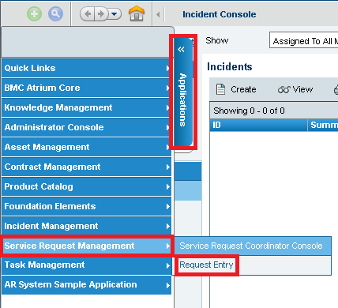
3
4
2
- To view a request that you have submitted to CNS in production remedy, you can do this in Service Request Management as well. Follow the steps above to access Service Request Management. Then,
- On the left hand side in Service Request Management, there is a box that says “Submitted Requests”.
- In this box is a section that says “Open Requests”. You can view all of your open tickets by clicking on “Open Requests”.
